Activity A6

**RESPIRATORY SYSTEM**

Build paper lungs

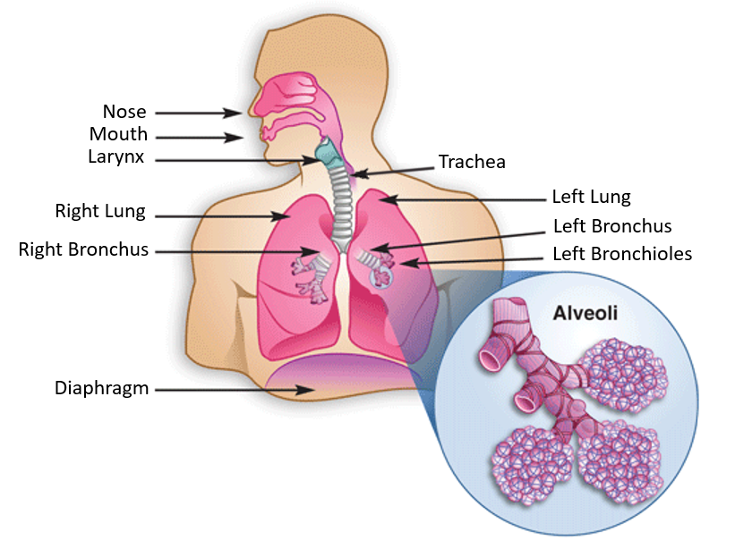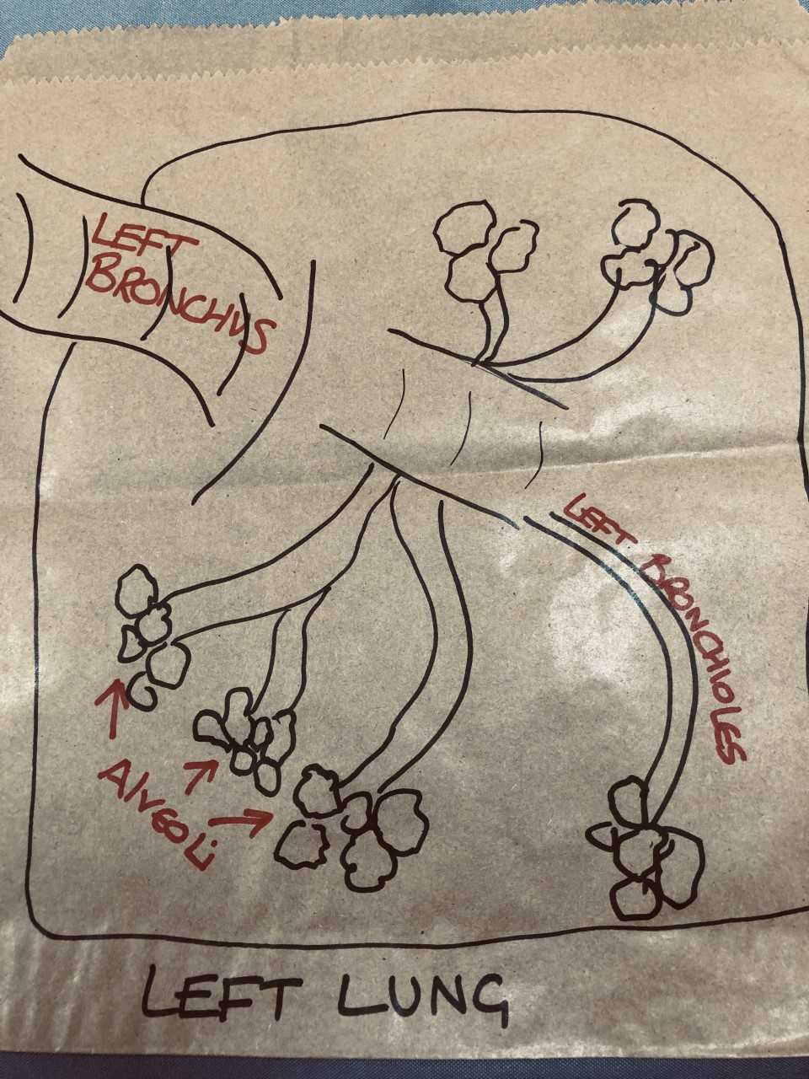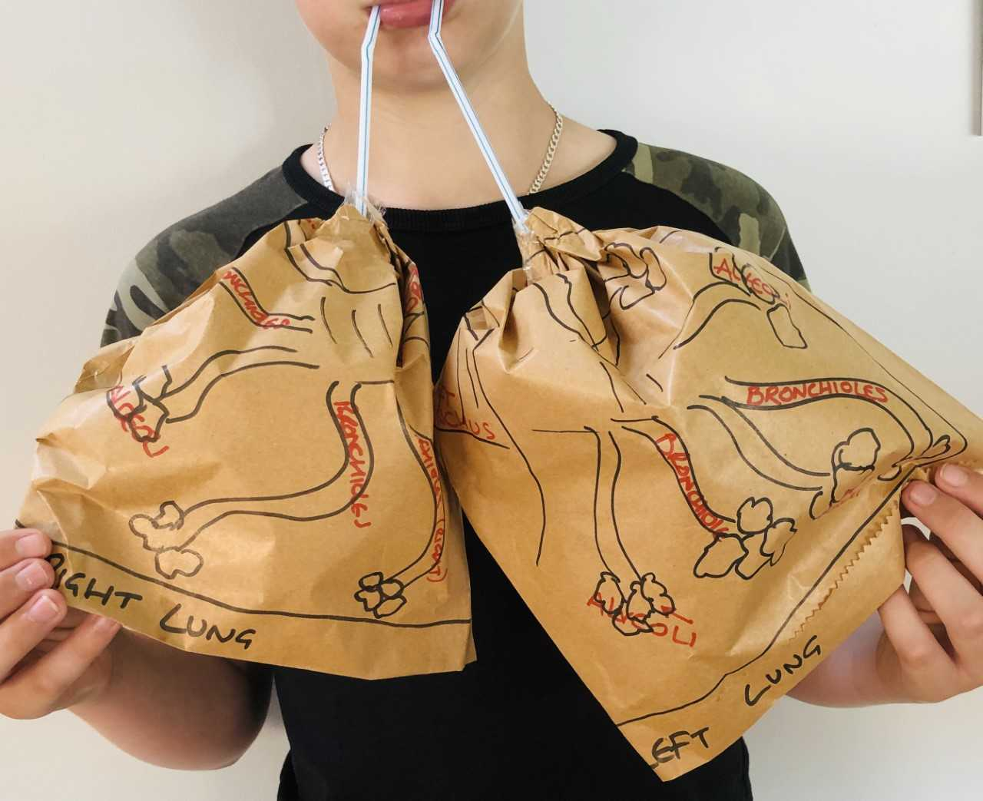

**Equipment needed:**

* Paper bags x2
* Straws x2
* Scissors
* Marker pens
* Diagram of lungs

**Steps:**

1. Take markers and draw what you see in the diagram of the lungs, on to the sides of the bag. Be sure to include the alveoli and the bronchiole.
2. Open the bags fully, slip the straw in the bag 2-3 inches and gather the top of the bag around the straw. Tape tightly, be sure you get a good seal so that air does not escape.
3. As you blow the lungs up, what is happening with the paper lungs is the exact opposite of what is happening with the lungs inside of your body. As you exhale, the paper lungs will fill up and your own lungs will become “deflated”.