**CREATE A CHECKLIST**

Choking Checklist

Activity A25

Using the words below, create a checklist of events to assist a casualty who is choking.

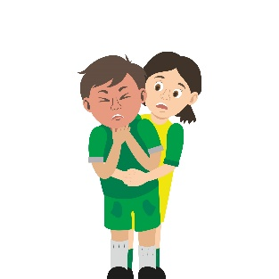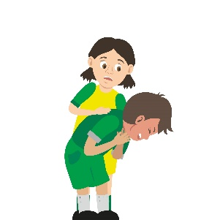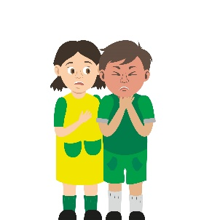

**CHECKLIST**

**------------------------------------------------------------------------------------------**

**------------------------------------------------------------------------------------------**

**-------------------------------------------------------------------------------------------**

**-------------------------------------------------------------------------------------------**

**-------------------------------------------------------------------------------------------**

**-------------------------------------------------------------------------------------------**

**-------------------------------------------------------------------------------------------**

**-------------------------------------------------------------------------------------------**

**--------------------------------------------------------------------------------------------------------------------------------------------------------------------------------------**



**thrusts**

**airway**

**throat**

**blocked**

**choking**

**face**

**back blows**

**999**

**cough**

**breathing**

**five**